Learning Cycle
A process to improve individual performance and team results by learning from experience.
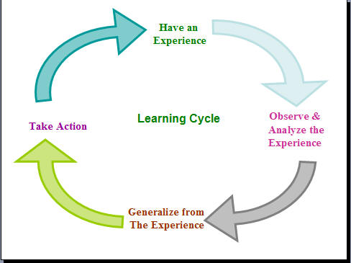
leadershipchamps.wordpress.com

- Assess Your Team’s Results: Describe your team’s grades as well as team members’ individual learning.

- Assess The Team’s Process. List the strengths and weaknesses of how your team works together.

- Identify Actions For Team Improvement: List at least three SPECIFIC improvements to implement. This is a great opportunity to make broad changes or just tweak the team dynamics. Some things to consider:
- Working together - What additional guidelines would help members of your team interact to stay on task, do the work correctly, and make sure everyone understands?
- Communication - Should you ask team members to slow down, speak more clearly, write more, use the interpreter more, talk things out more?
- Participation - What can the team do to help a more passive member of the team become involved - to take on more active roles and ask questions? Or conversely, what can the team do to make sure that one person doesn't take over, but involves everyone in the work?

4. Turn in this assignment by ___________________________.

