Learning Cycle
A process to improve individual performance and team results by learning from experience.
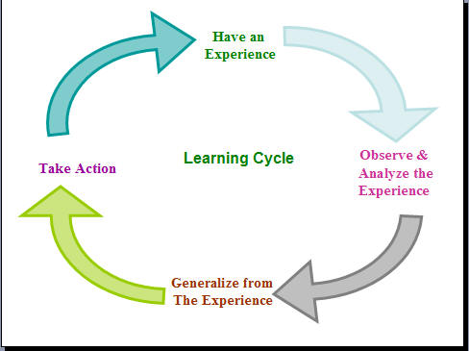
leadershipchamps.wordpress.com

- Assess Your Team’s Results: Describe your team’s grades and team members’ individual learning since the last learning cycle.

- Review the Team’s Last Learning Cycle: Describe the success (or failure) of each of your team’s improvement ideas from the last learning cycle.

- Assess The Team’s Process. List the strengths and weaknesses of how your team works together.

- Identify Actions For Team Improvement: List at least one SPECIFIC improvement that would improve your team’s performance and/or process.

- Turn in this assignment by _____________________________.

